Yersinia Package Description

Yersinia is a framework for performing layer 2 attacks. It is designed to take advantage of some weaknesses in different network protocols. It pretends to be a solid framework for analyzing and testing the deployed networks and systems. Attacks for the following network protocols are implemented in this particular release:

* Spanning Tree Protocol (STP)
* Cisco Discovery Protocol (CDP)
* Dynamic Trunking Protocol (DTP)
* Dynamic Host Configuration Protocol (DHCP)
* Hot Standby Router Protocol (HSRP)
* 802.1q
* 802.1x
* Inter-Switch Link Protocol (ISL)
* VLAN Trunking Protocol (VTP)

Source: https://github.com/tomac/yersinia  
[Yersinia Homepage](https://github.com/tomac/yersinia) | [Kali Yersinia Repo](https://gitlab.com/kalilinux/packages/yersinia)

* Author: Alfredo Andres Omella, David Barroso Berrueta
* License: GPLv2

Tools included in the yersinia package

yersinia – Network vulnerability check software

root@kali:~# yersinia -h  
    ۲�۲��  
   �������۲�  
 ۲��������۲�  
�����۱����������  
����۱������������  
����۱�������������               Yersinia...  
������������������۲��  
۲���۱��������������۲��         The Black Death for nowadays networks  
 ������۱�����������������  
 �������۱���������������۲�             by Slay & tomac  
  ۲�����۱�������������������  
     �����۱�������������������        http://www.yersinia.net  
      ۲����۱���������������۲            yersinia@yersinia.net  
       ۲�����۱���������������  
         �������۱����������۲�  
         �۲���������۱�������     Prune your MSTP, RSTP, STP trees!!!!  
             �������������۲�  
  
  
Usage: yersinia [-hVGIDd] [-l logfile] [-c conffile] protocol [protocol_options]  
       -V   Program version.  
       -h   This help screen.  
       -G   Graphical mode (GTK).  
       -I   Interactive mode (ncurses).  
       -D   Daemon mode.  
       -d   Debug.  
       -l logfile   Select logfile.  
       -c conffile  Select config file.  
  protocol   One of the following: cdp, dhcp, dot1q, dot1x, dtp, hsrp, isl, mpls, stp, vtp.  
  
Try 'yersinia protocol -h' to see protocol_options help  
  
Please, see the man page for a full list of options and many examples.  
Send your bugs & suggestions to the Yersinia developers <yersinia@yersinia.net>  
  
  
  
MOTD: The Hakin9 magazine owe money to us... 500 Euros

Yersinia Usage Example

root@kali:~# yersinia -G

[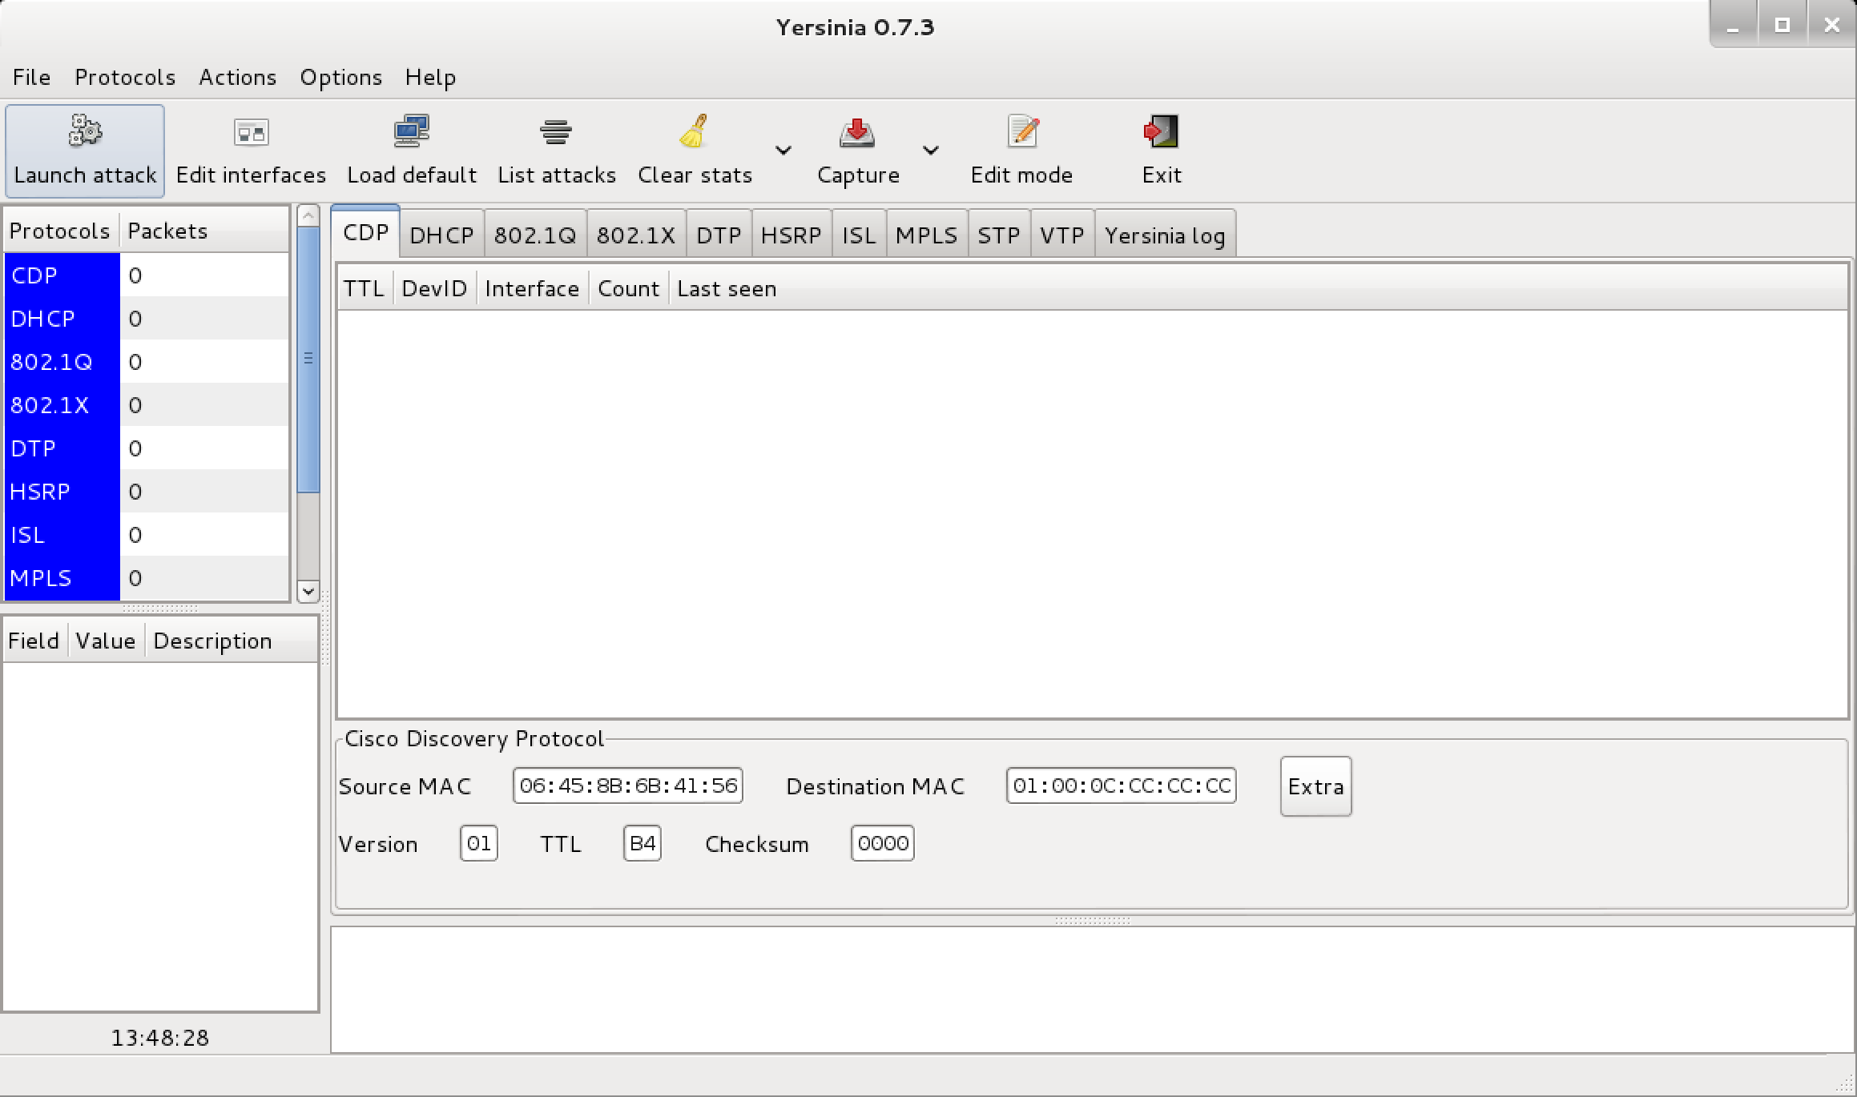](http://tools.kali.org/wp-content/uploads/2014/02/yersinia.png)